Nama : Michael Geraldin Wijaya
NIM : 2602238021
Class : LC95
ASSURANCE OF LEARNING
- PSEUDOCODE
Declare integer N,T,j,i,c,p,q
Input N
Declare integer array mat ukuran N*N
If(N>2) then
For i:=0 to N
For j:=0 to N
Input mat[i][j]
End for
End for
Declare integer x
Set c = N/2
For x:=0 to 1 (loop once, so the break statement can be used)
If mat[c][c]==0 then Display “The value of centroid can’t be 0”
Break
End if
Display (centroid at c,c)
Set p = 0
Set q = 0
If mat[c + 1][c] == mat[c][c] OR mat[c][c + 1] == mat[c][c]
OR mat[c][c - 1] == mat[c][c] OR mat[c - 1][c] == mat[c][c] then
For i:=c+1 to c-1
For j:=c+1 to c-1
If mat[i][j]==mat[c][c] then
If i==c AND j==c then continue
End if
Set p++
End if
End for
End for
Else if mat[c + 1][c + 1] == mat[c][c] OR mat[c + 1][c - 1] == mat[c][c]
OR mat[c - 1][c + 1] == mat[c][c] OR mat[c - 1][c - 1] == mat[c][c] then
For i:=c+1 to c-1
For j:=c+1 to c-1
If mat[i][j]==mat[c][c] then
If i==c AND j==c then continue
End if
Set q++
End if
End for
End for
End if
Display “Nearest same elements is at:”
If p>0 then
For i:=c+1 to c-1
For j:=c+1 to c-1
If mat[i][j]==mat[c][c] then
If i==c+1 AND j==c OR i==c AND j==c+1 OR i==c AND j==c-1 OR i==c-1 AND j==c then
If i==c AND j==c then continue
End if
Display (i,j)
End if
End if
End for
End for
Else if p==0 then
If q==0 then Display “ no nearest element.”
Else if q>0 then
For i:=c+1 to c-1
For j:=c+1 to c-1
If mat[i][j]==mat[c][c] then
If i==c AND j==c then continue
End if
Display (i,j)
End if
End for
End for
End if
End if
End for
Else Display “Size of matrix must be more than 2*2”
End if

FLOWCHART
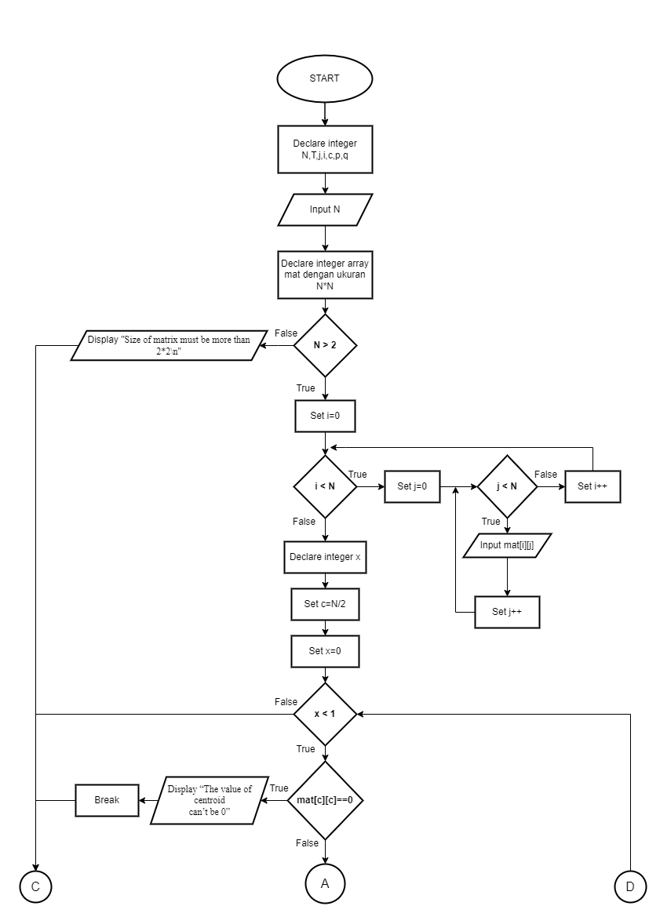

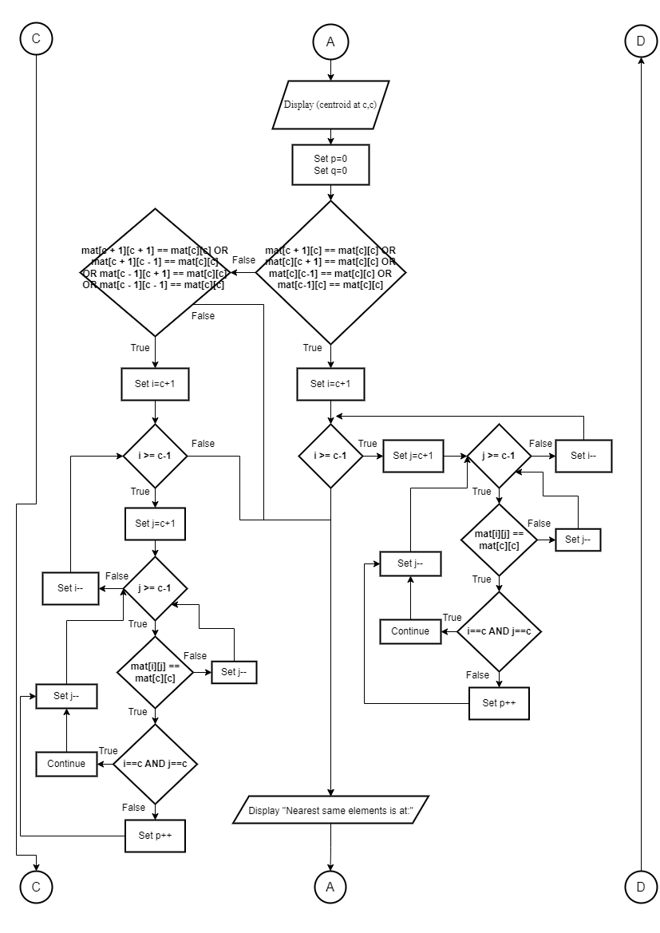

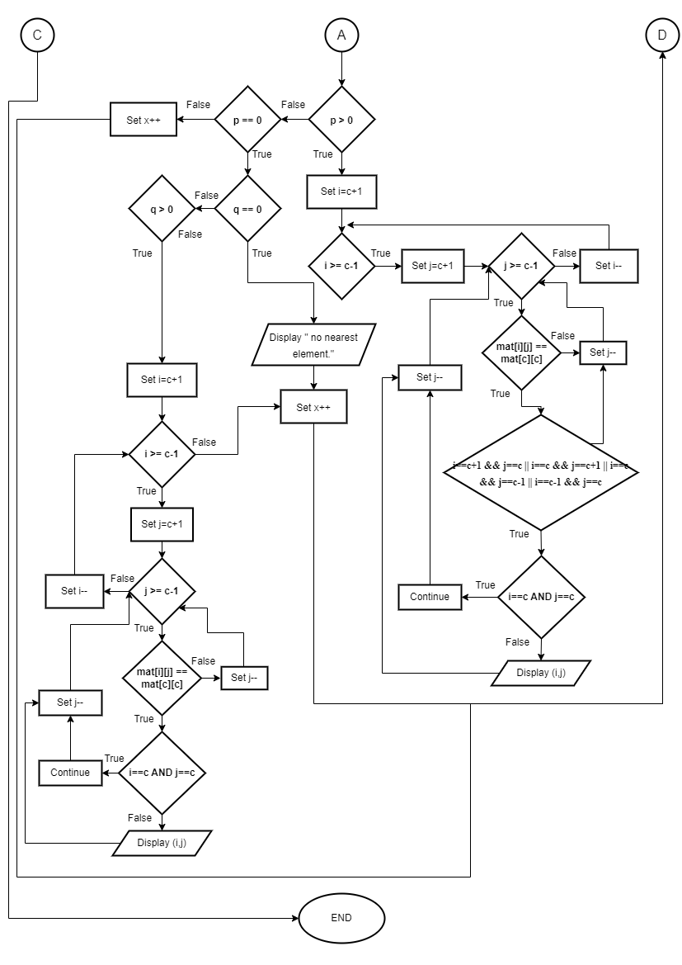

- PSEUDOCODE
Struct Friend(
string name
string phoneNumber
string address
)as array friends
Function searchFriends(string pointer nameee)
Declare integer i, found
Set found = 0
For i:=0 to strlen(friends)
If strstr(friends[i].name, nameee not NULL then
Display friends[i].name friends[i].phoneNumber friends[i].address
Set found = 1
End if
End for
Return found
End function

Module main()
Declare integer i
Declare string namee
Declare char stopInput
Set stopInput = Y
Display “Input data: Name, Phone Number, and Address”
Set i = 0
While stopInput == Y
Display “Name: ”
Input friends[i].name
Display “Phone Number: ”
Input friends[i].phoneNumber
Display “Address: ”
Input friends[i].address
Display “Want to input data again? (Y/N): ”
Input stopInput
Set i++
End While
Display “Enter a name to search: ”
Input namee
Declare integer founds
Set founds = searchFriends(namee)
If founds not 1 then Display “Data Not Exist”
End if
End module

FLOWCHART

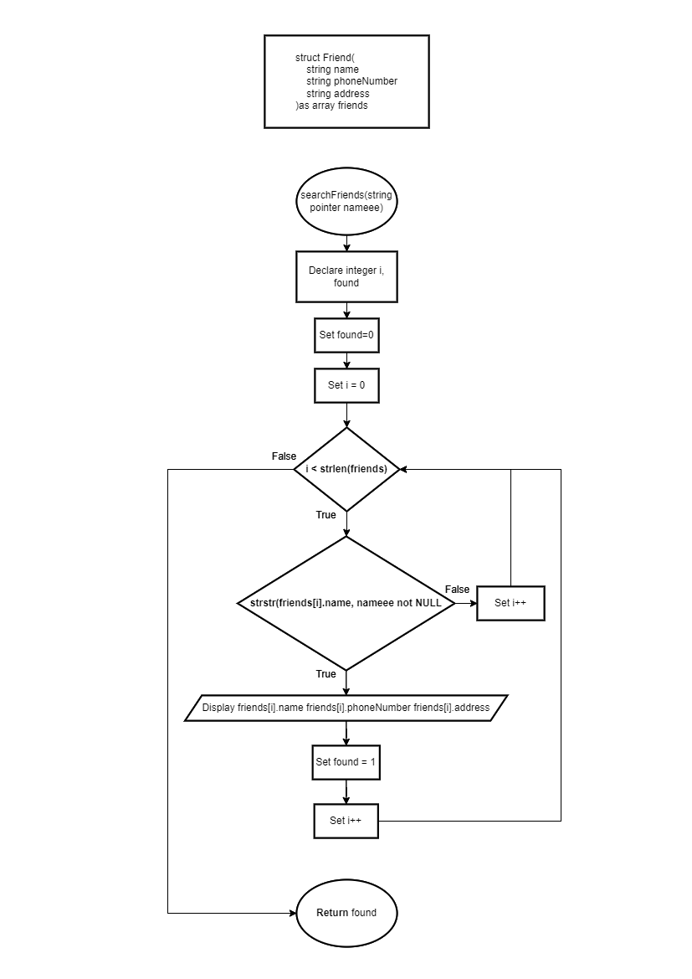
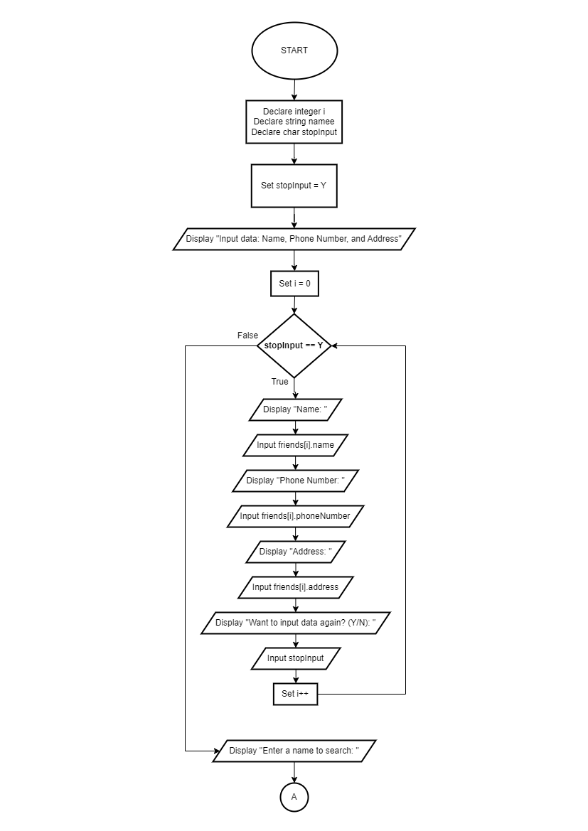

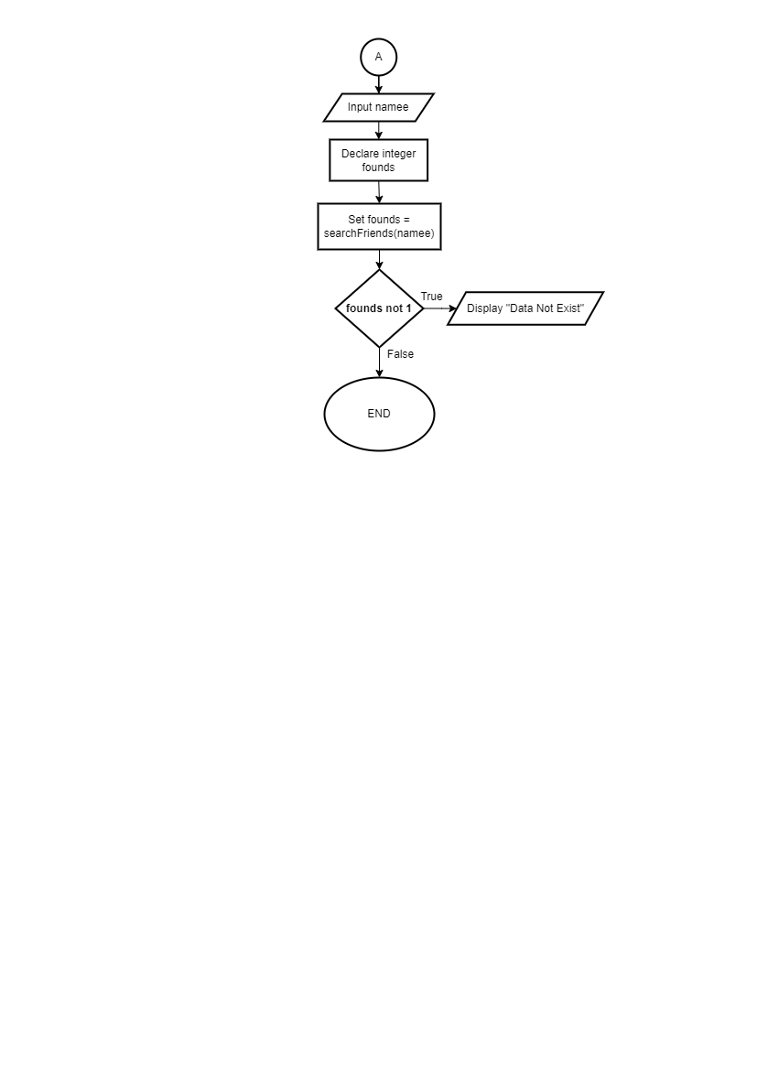

- PSEUDOCODE
Function countArea (integer array matrix, integer n)
Declare integer x,y,area
Set area = 0;
For x:=0 to n
For y:=0 to n
If matrix[x][y] == 1 then
Set area++
Set matrix[x][y] = 0
If x > 0 AND matrix[x-1][y] == 1 then set area+= countArea(matrix, n)
End if
If x < n - 1 AND matrix[x+1][y] == 1 set area += countArea(matrix, n)
End if
If y > 0 AND matrix[x][y-1] == 1 then set area += countArea(matrix, n)
End if
If y < n - 1 AND matrix[x][y+1] == 1 then set area += countArea(matrix, n)
End if
End if
End for
End for
Return area
End function
Module main()
Declare integer N, i, j
Declare integer array mat1, mat2
Input N
For i:=0 to N
For j:=0 to N
Set mat1[i][j]=0
Set mat2[i][j]=0
End for
End for
For i:=0 to N
For j:=0 to N
Input mat1[i][j]
End for
End for
For i:=0 to N
For j:=0 to N
Input mat2[i][j]
End for
End for
Declare integer area1, area2
Set area1 = countArea(mat1, N)
Set area2 = countArea(mat2, N)
If area1 > area2 then Display “Object 1 is bigger”
Else if area1 < area2 then Display “Object 2 is bigger”
Else Display “Object 1 and 2 has the same size”
End module

FLOWCHART
